Usecase Diagram

• Identify various functionalities to be developed. They are assumed as Functional requirements for your project

Functional Requirements:

1. User registration and login: Users should be able to create an account and log in to access their personalized news feed.
2. News feed: Users should be able to view a personalized news feed based on their interests, which can be updated in real-time.
3. Article categorization: Articles should be categorized based on topics and interests, allowing users to easily find articles that are relevant to their interests.
4. Article search: Users should be able to search for articles based on keywords and topics.
5. Article sharing: Users should be able to share articles on social media platforms and email.
6. User preferences: Users should be able to specify their interests and news sources, allowing for a more personalized news feed.

• For all the Functional requirements, identify Use cases with pre and post conditions.

Draw Use case diagram. Use case diagram should include level 1 and level 2

Level 0:- UseCases

1. Login/Registration: A user can create an account or log in to an existing account to access personalized news.
2. View News Feed: A user can view a news feed of articles based on their interests and news sources.
3. Follow/Unfollow News Sources: A user can follow or unfollow news sources to receive articles from that source.
4. Follow/Unfollow Topics: A user can follow or unfollow topics to receive articles about those topics.
5. Search for Articles: A user can search for articles based on keywords or topics.
6. View Article Details: A user can view the details of an article, including its title, author, source, and content.
7. Rate Articles: A user can rate articles based on their relevance and quality.
8. Receive Notifications: A user can receive notifications when new articles are published on topics they are interested in.

Level 1 Use Cases:

1. Edit Profile: A user can edit their profile, including their interests and news sources.
2. View Archive: A user can view an archive of previously published articles.
3. Manage Advertisements: The system can display advertisements, with options for controlling the placement and frequency of ads.
4. Multi-language Support: The system can display articles in multiple languages, allowing users to select their preferred language.
5. View User Ratings: A user can view ratings of articles by other users.

UseCase Diagram

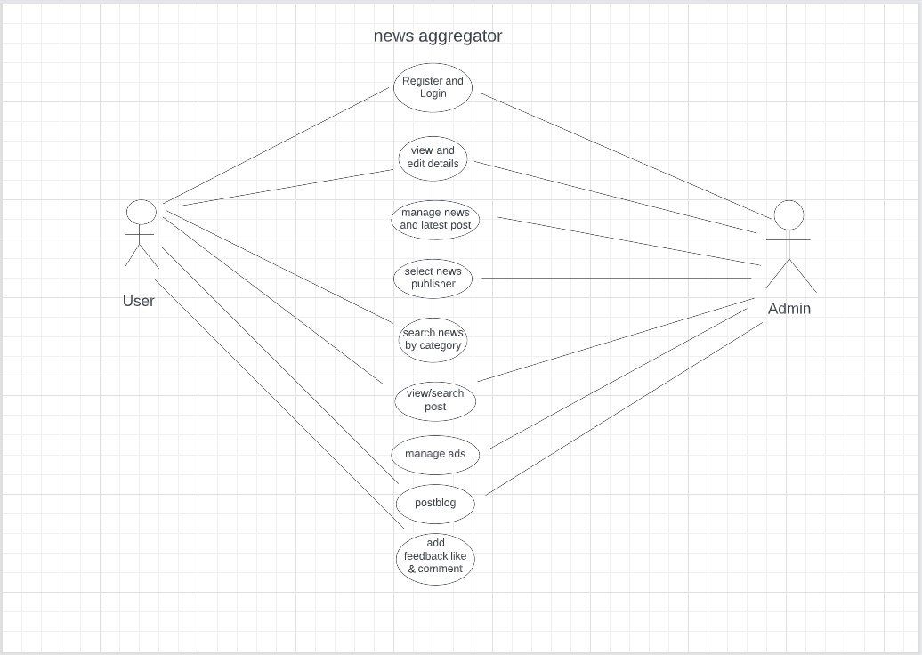

View News Feed:

Pre-condition: The user must be logged in to the personalized news aggregator.

Post-condition: The user can view a news feed of articles based on their interests and news sources.

• Expand the same use cases with classes: Identify various classes , attributes and

operations required for the use cases.

Sequence Diagram

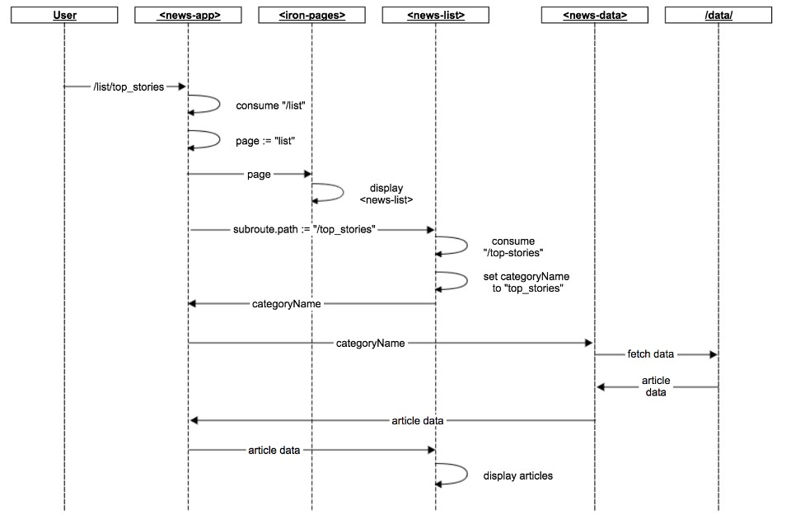

• Draw Class diagram for the classes and Sequence diagram for the sequence flow of

operations identified in the use cases scenarios

Class Diagram

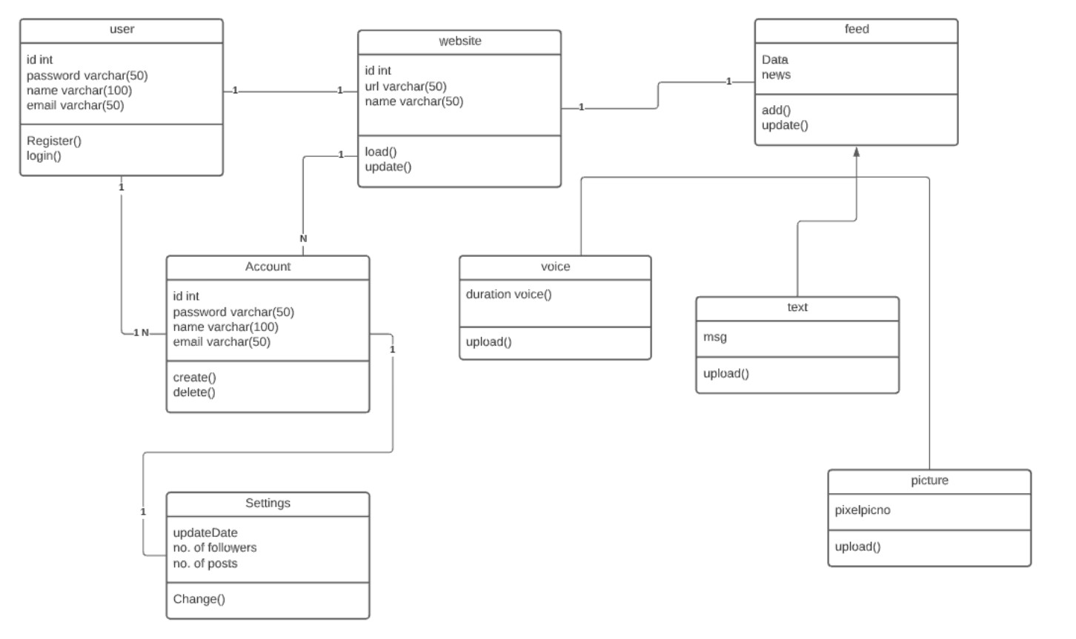

Team Name:-Error 404

Rakshit Somkuwar:-(21BCS122)

Sankalp Chiprikar:-(21BCS027)